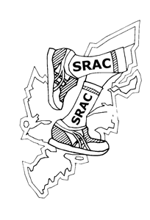 | Stornoway Running and Athletics Club

SENIOR NEWSLETTER – February 2018

Guten tag members hope you are all training well. It’s been a tough winter training on the island especially for the roads runners with all the snow and ice but half marathon season is nearly here where all that hard work will pay off! This year a group of SRAC runners are going to the Alloa Half in March as a wee change from the normal Inverness pilgrimage. Focus can then turn to training for the Stornoway Half, its shaping up to be a great event with record numbers signing up already!

The final race in the local XC series took place this month as did the National XC in Falkirk. Our favourite Austrian club member (the Prince of Linz) Gerald was over in Scotland this month, and took part in the National during his trip. There will be a report from Gerald on his experience in Callendar park in the March newsletter!

2018 Membership

Annual club membership renewals are now due please, it’s an online process again this year. New members also welcome to join - https://srac.org.uk/membership/

Grand Prix Series Road Races 2018

The 2018 club Grand Prix races have been decided, full details will be emailed to members soon! Note you can choose between Inverness and Alloa, only one of the events will count towards your points.

- Inverness Half Marathon and 5k (11/3/18) or Alloa Half Marathon (18/3/18)
- Pentland Road 10k and 5k (TBC)
- Stornoway Half Marathon & 10k (26/5/18)
- Club social event, possible Clisham climb with a meal in Harris afterwards (July/August 18)
- Harris Half Marathon (7/7/18)
- Westside 10k and 5k (TBC)
- Calbost Classic 7 miler (TBC)
- Berneray 10k (TBC)
- Scalpay 10k (TBC)
- Club social run and meal for seniors (approximately 10k in a different location each year, around October/November time)
- Ness 10k and 5k (TBC)

Glenbrittle forest 10 mile trail race (Norm’s report)

A few of us travelled over the sea to the annual Glenbrittle Forest trail race in Skye this month, it’s part of Skye Running club’s winter race series. It turned into a bit of an unofficial club trip with over 10 members planning to go but for various reasons in the week leading up to the race quite a few had to pull out leaving just Amy, Alison, Murdo Alex and myself traveling across.

The race was set in a stunning location starting next to the famous fairy pools in Glenbrittle below the snow-capped Cuillin mountains, we were lucky with the weather is was a beautiful day. The route was tough but fun with over 1,500 ft of climbing, I had run it before and told the guys it’s just like doing two loops of the castle grounds – I misremembered oops! The whole loop was on good hard land rover track through the forest and the views round the course were stunning, here’s a couple of Amy’s pics:
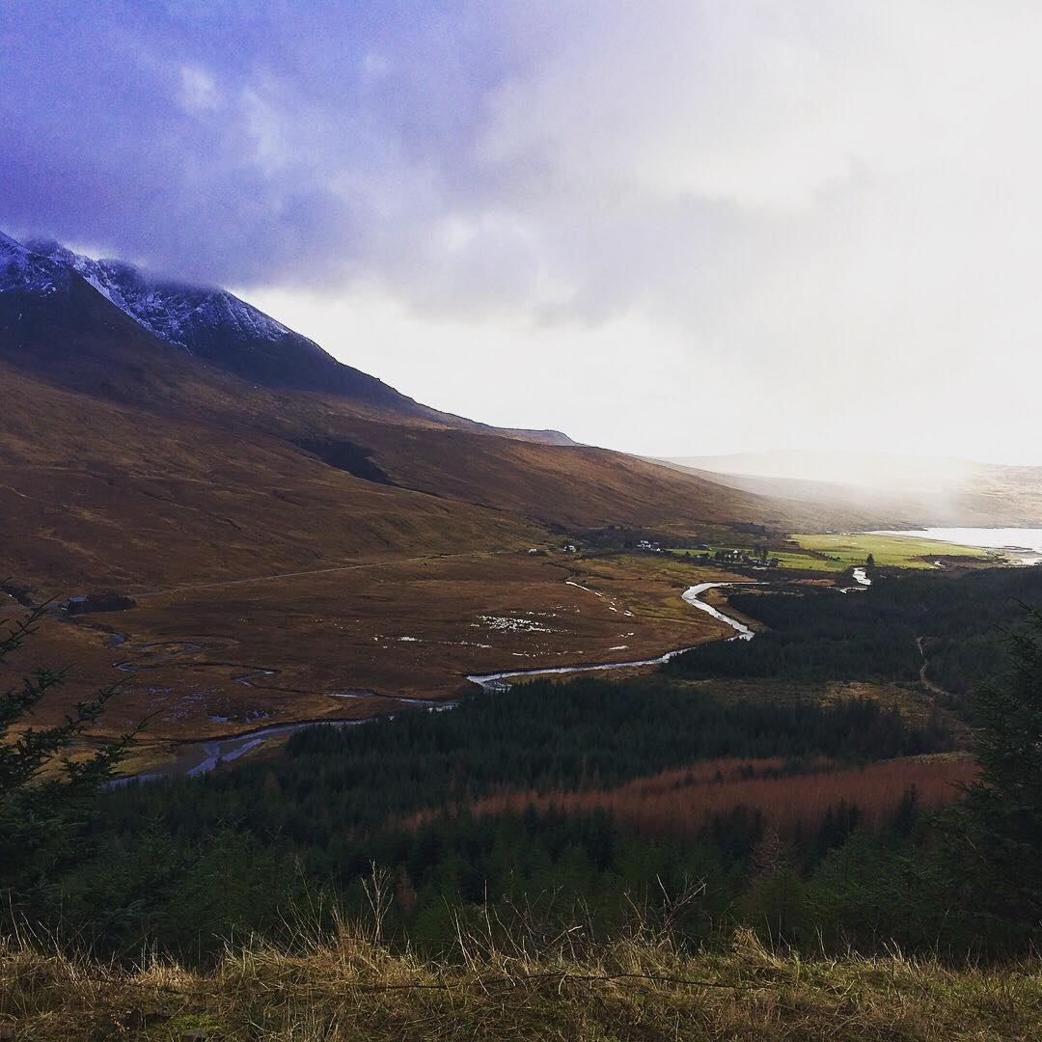

Murdo Alex led from start to finish with a really strong run on the hilly course and I scraped round a distant second, former member Angus Museum was third. Alison and Amy had great runs too but were quick to remind me of my dodgy castle grounds comparison! We then joined the Skye runners at the Carbost Inn nearby for some soup, sannies and refreshments. It was at this point we found out our ferry back to Harris that night was going to be cancelled with a technical, oh no! Murdo and I returned to my folks place for another night and banquet, while Amy and Alison lived it up in Portree by making use of the Calmac compensation scheme and checking into a 5 star luxury hotel.

We would highly recommend this race it was only £5 to enter and easy to get to, definitely one for a club road trip next year!

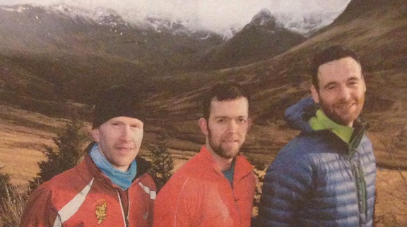
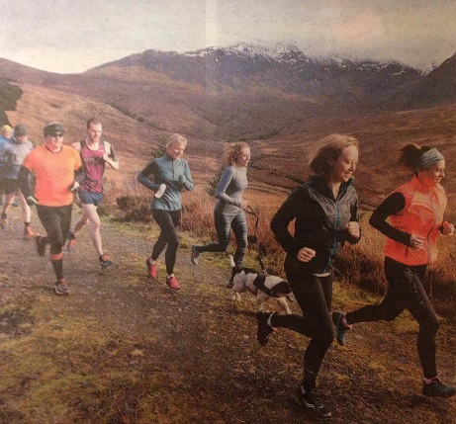
Amy & Alison – Free Press back page stars. Also new boy band formed after the race – name suggestions welcome?

L&H XC

Lewis & Harris cross country race three was held this month with another great turnout on the Castle green. It was a rerun of the Willie’s new route from race two but this time without the snow! Murdo Alex was first again over the challenging course and with that secured first place male in the series overall, second in the series was Allan Morrison, and third chairman Stephan. First place female over the series was Elly Fletcher, second Jayne Miller, and third Kirsty Brightwell. Well done to all who completed the series it’s great to see more seniors taking part!

The cross country season is almost over but there is one more race, the Western Isles XC champs in Uist on 17 March.

National Cross Country in Falkirk

Four senior members took part in the National XC champs in Falkirk on 24 Feb – wee Gerald Kalchauer, Allan Morrison, Murdo Alex and Allan Maciver. Murdo was our highest placed finisher in 159th place, a great finish given the high level of competition! We didn’t have any SRAC senior woman taking part but Glasgow based Holly Maciver (Howie’s daughter) had a great run coming 74th in the ladies race running for Garscube. Full report from Gerald in the next newsletter.

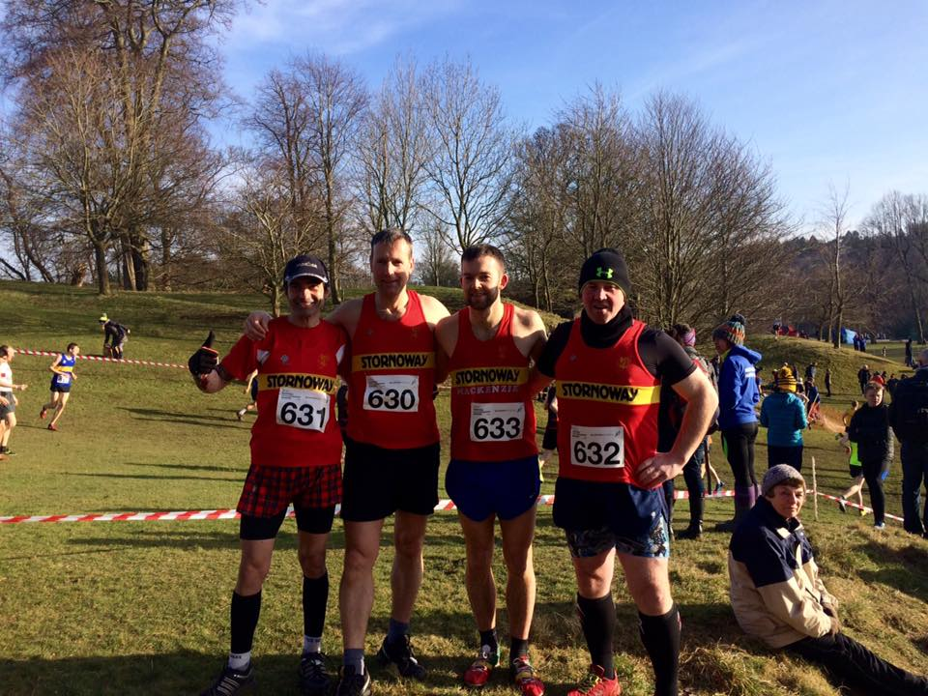

Stornoway Half Marathon and the HEB 3

It looks like it will be a record year for the Stornoway half we are only in February and we have hit 170 entries. Two thirds of the entries so far are from people off island we can’t wait to give them a big Hebridean welcome, announcement coming soon about the ceilidh. We are likely to hit the current entry limit of 200 soon so make sure you get signed up! www.entrycentral.com/Stornoway

The Harris half joined the Barrathon on the sold out list earlier this month, selling out in record time. But there are still some places left in the Skye, Benbecula and Stornoway half’s - if you’re planning to complete a Heb 3 this summer srac.org.uk/heb3/

Racing roundup

Andrew Joyce made a great start to the season finishing 5th place at the Run With the Wind Half Marathon in Strathaven, in a time of 1.18.24.

John ‘Caskie’ Macaskill continued his Boston Marathon preparation with a 1.23.39 at the Kinloss to Lossiemouth Half Marathon.

Other news

Good bye Bill! Everyone at the club would like to wish Bill Ferguson all the best in his move back to the mainland, Bill has been a member of SRAC since the year 2000.

Louise’s London Marathon – Louise Henderson is running London to raise money for Cancer Research UK you can sponsor her here https://www.justgiving.com/fundraising/louise-henderson26

Races coming up

11 March Inverness Half Marathon
17 March Western Isles Cross Country, in Uist
17 March Benbecula 10k
18 March Alloa Half Marathon
29 March Wacky Race 6
April (TBC) Pentland Road 10k and 5k
26 May Stornoway Half Marathon and 10k

Happy Running
SRAC Senior Sub Committee

